Yacht information Beneteau Oceanis 393, Tiffany

Technical data |  | Comfort
Built in year  Call sign  Sail number  Length over all  Max beam  Draft  Free sailing height  Displacement  Engine  Propeller  Bowthruster  Fuel capacity  Water capacity  Battery capacity, consume  Battery capacity, engine  Berths in cabins  Berths in saloon  Limited number of guests | 2005  S - xx  11,94 m  3,96 m  1,90 m  17,0 m  7,78 tons  56 HP  3 blades,  Yes  138 l  475 l  1 x 140 Ah  1 x 110 Ah  6  2  8 | Stove with oven  Pressurized water  Hot water  Shower inside  Toilet/s  Fridge  Freezer  Cabin heater  Various equipment  Primary anchor  Secondary anchor  Moorings and fenders  Life raft  Harness  Life vests  Charter equipment | Yes  Yes  Yes  Yes  2  Yes  Yes (small)  Yes  Yes  Yes  Yes  Yes  Yes  Yes  Complete
 |  | Security equipment | Complete
Equipment |  | Pillows and blankets | Yes, for 8 persons
Mainsail  Genoa (130 %)  Storm jib  Spinnaker  Rig  Headstay  Spinnaker boom  Spinnaker gear | Semifull b.  Yes, furling  No  No  Masthead  Furling  No  No | Bedlinen  Galley  Spi  equipment  Rubber dinghy  Outboard motor  Layout | Option  Complete  No  Option  Option
 |  | 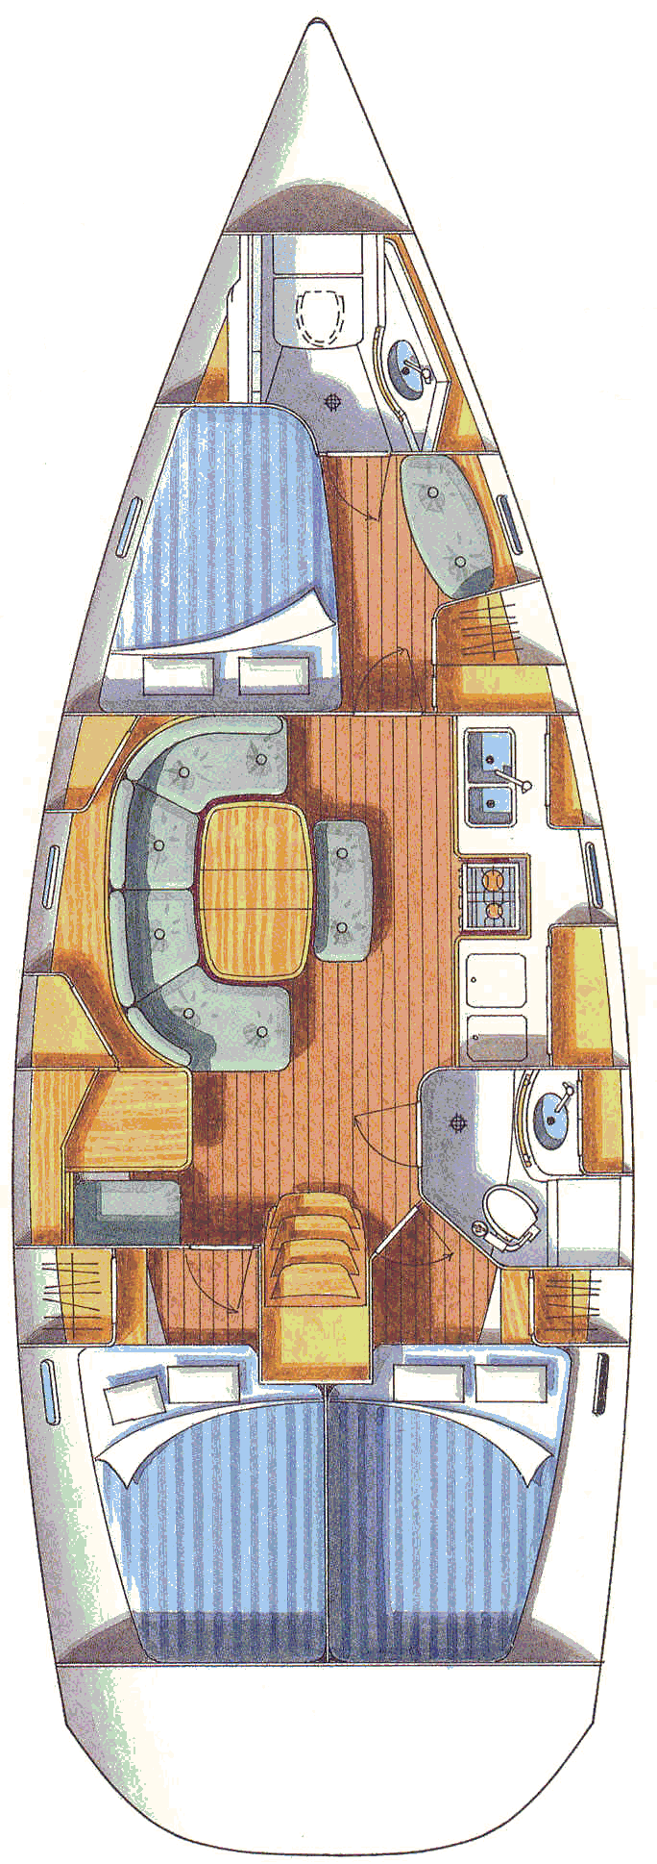
Deck
Teak deck  Windlass  Genoa winches  Halyard winches  Spinnaker winches  Halyards to cockpit  Steering  Cockpit table  Sprayhood  Cockpit shower  Swimming ladder | No  1 electricfwd  Yes 48 ST  Yes  No  Yes  Wheel  Yes  Yes  Yes  Yes
Technical equipment
Compass, magnetic  Log  Depth-sounder  Wind instrument  Navigator in cockpit  Autopilot  VHF  Radio / Stereo  Shore power  Battery charger | Yes  Yes  Yes  Yes  GPS / Plotter  Yes  Yes  Yes, with CD  Yes  Yes

NO SMOKING INSIDE THE YACHT

